REVA HACK</> 2021

Elevator Pitch

**TECHKNIGHTS**

NITHESH GOWDA B N

PRAJWAL G M

RACHANA K

SURAJ KARTHIK S A

GYM EXERCISE MONITORING POWERED BY ML

**12th November, 2021**

# Overview :

In recent times we are facing many fatality cases due to excessive workouts in gyms. People tend to workout more than required hence it leads to several heath complexities. Therefore we propose this project in which people can keep a track on their gym workout routines.

# Goals :

1. We claim to plot all the joints of the human body which helps us keep track of human body.
2. We claim that people can keep track of various exercises during gym workout routine.
3. By keeping track we can also provide caution signal to the user when the user is overdoing the workout .

# Working Methodology and Specifications :

Implementation of the project is made by using the jupyter notebook. Where we make use of python programming language, it provides large number of libraries which supports and accommodates ML applications, libraries used are :

* Open CV
* Mediapipe
* Numpy
* Streamlit

By using streamlit we have created the frontend of our web application. Here we are mainly focusing on the landmark functionality of mediapipe library which helps to locate various joints in the human body. The diagram shown in the following slide depicts the joints markings.

DIAGRAM : 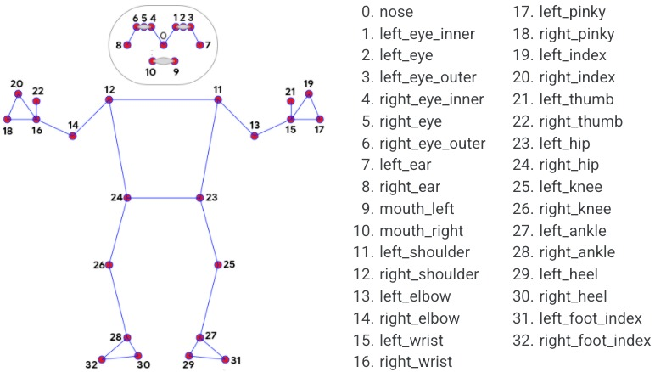

# Links and other Information:

* <https://drive.google.com/drive/folders/10Ty651DNfElgVBHgcCuHmHxESwCOxEvG?usp=sharing>
* <https://github.com/NitheshGowda16/Gym-excercise-tracker>